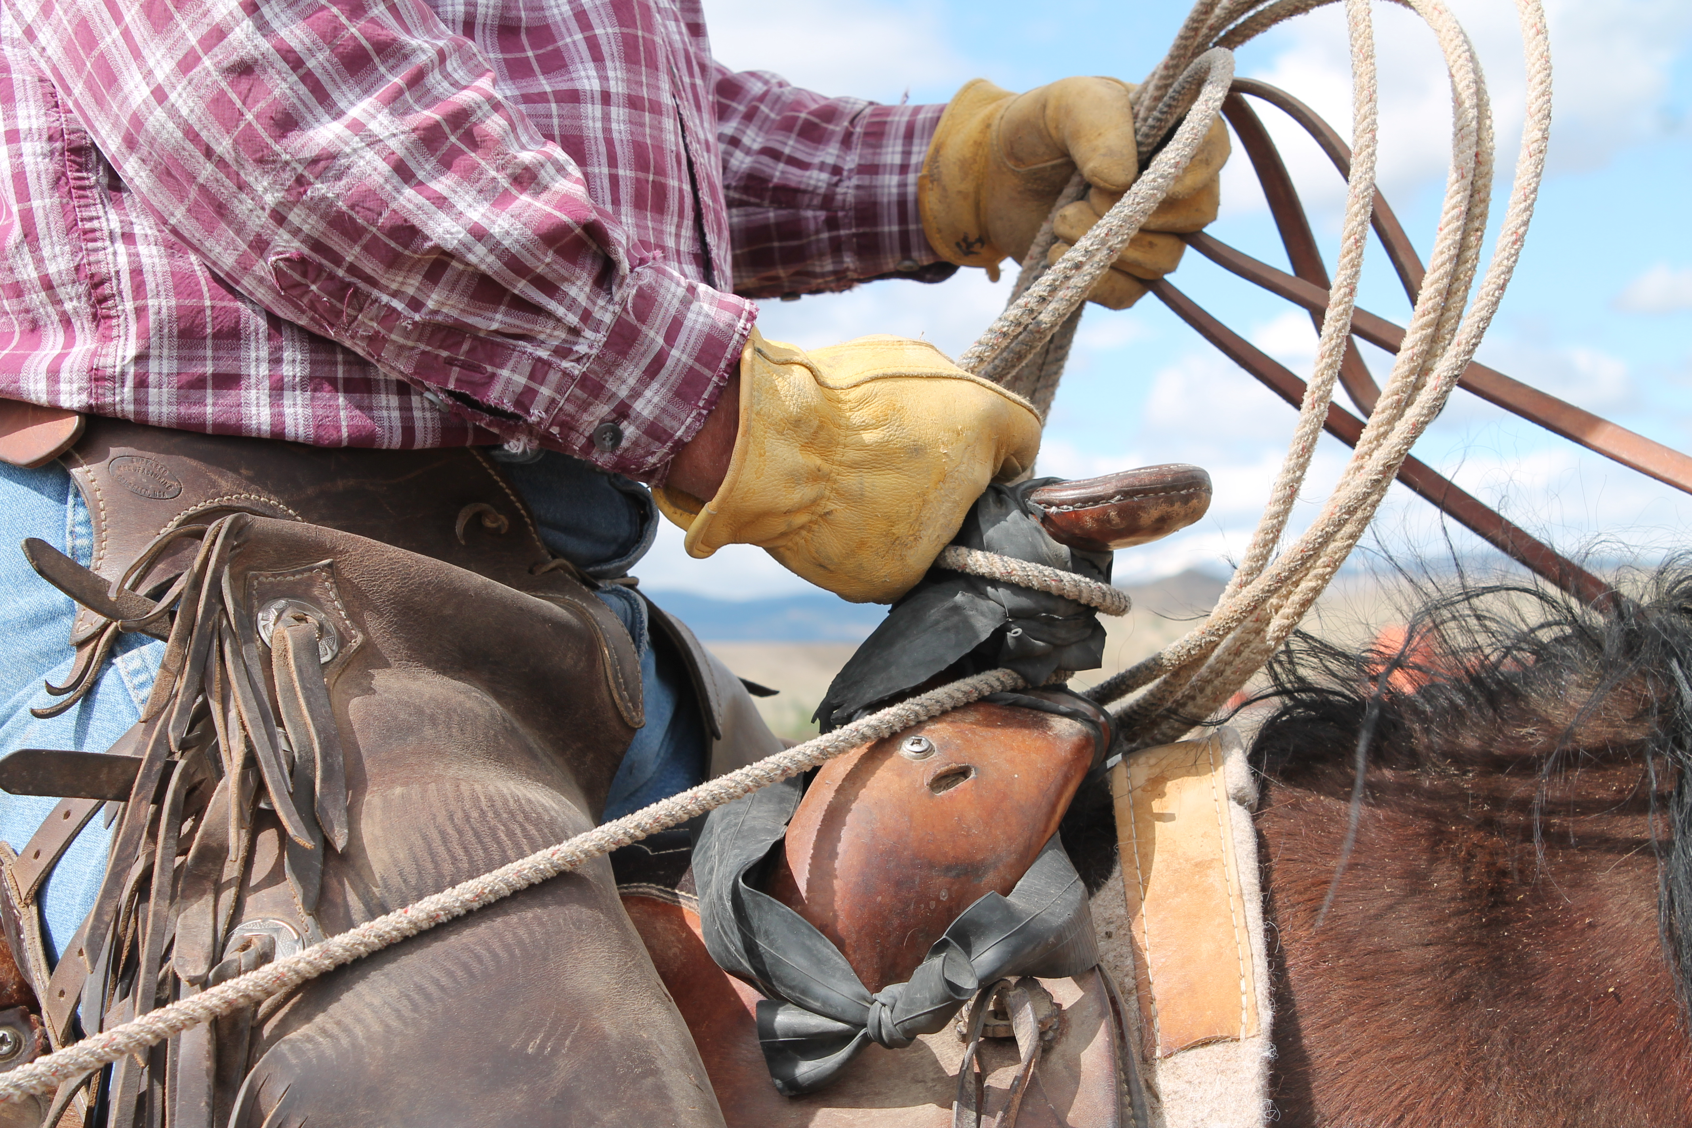
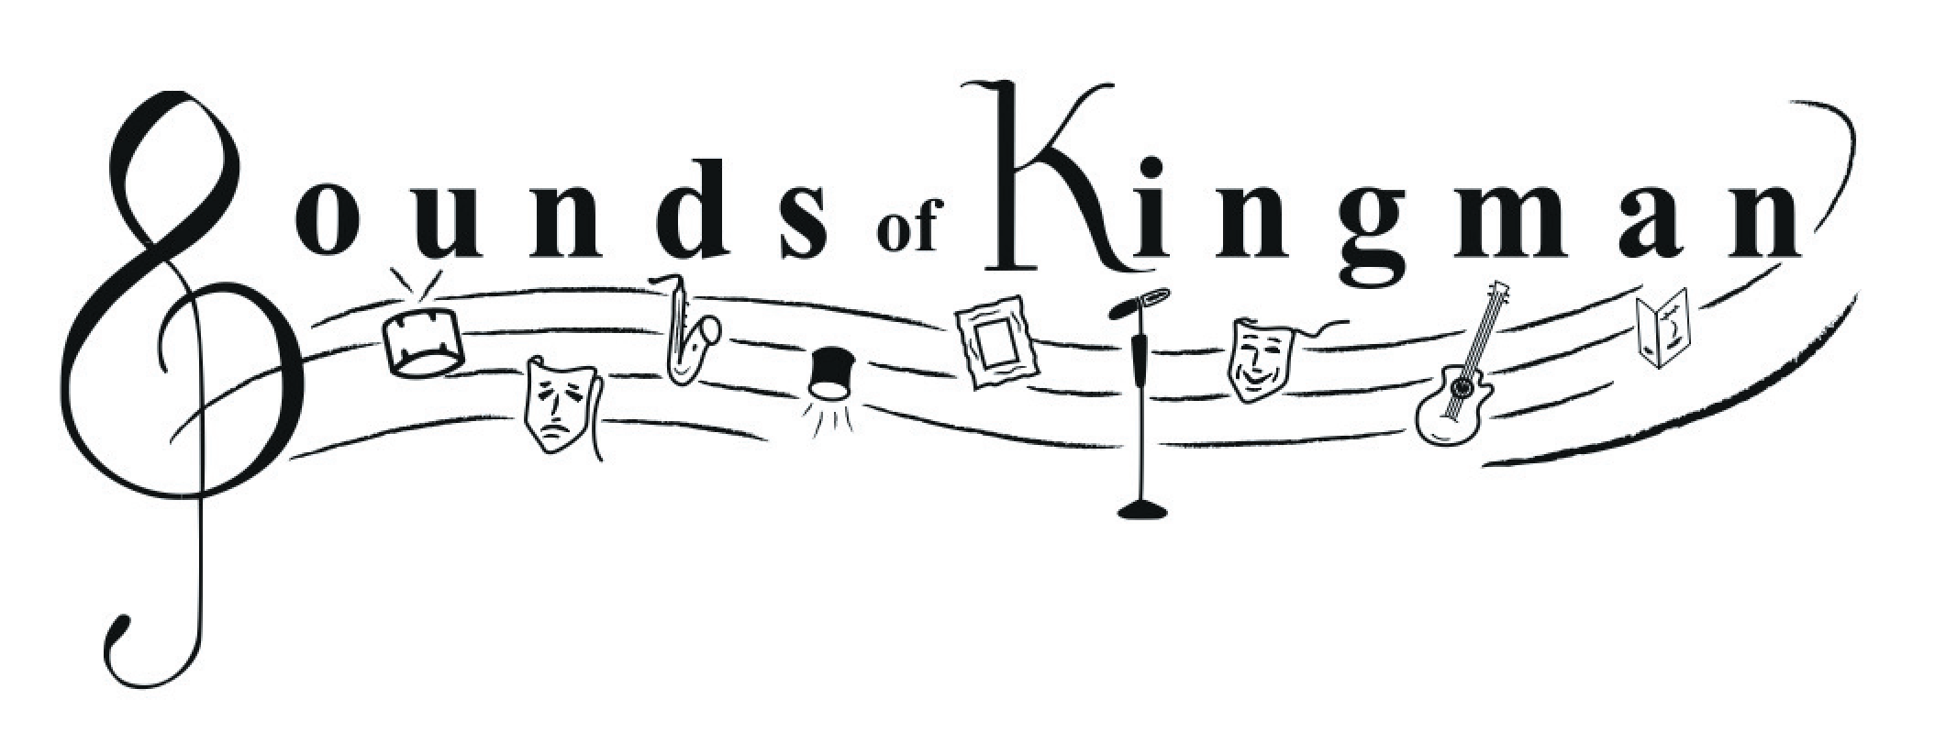

presents
-------------------------------------

cowboy poetry
through mohave county ranching
-------------------------------------
Saturday, 1/24/2026
1:00pm
Kathryn Heidenreich Center
1776 Airway, Kingman, AZ
Kathy Smith
a fifth-generation member
of a Mohave County
ranching family

brings Mohave County
ranching history to life,
cowboy poetry style!
Cowboy Poetry & Western Music Gatherings are held all across the West, celebrating the rich traditions and stories of the region with music and poetry. These events reflect a deep yearning to revisit simpler times and to explore the vibrant history of the American West.

Kathy offers a historical perspective on cowboy poetry and delves into the history of Arizona’s cowboy poets. She’ll recite poetry from classic cowboy poets and some of her own, all viewed through the lens of Mohave County ranch history.

