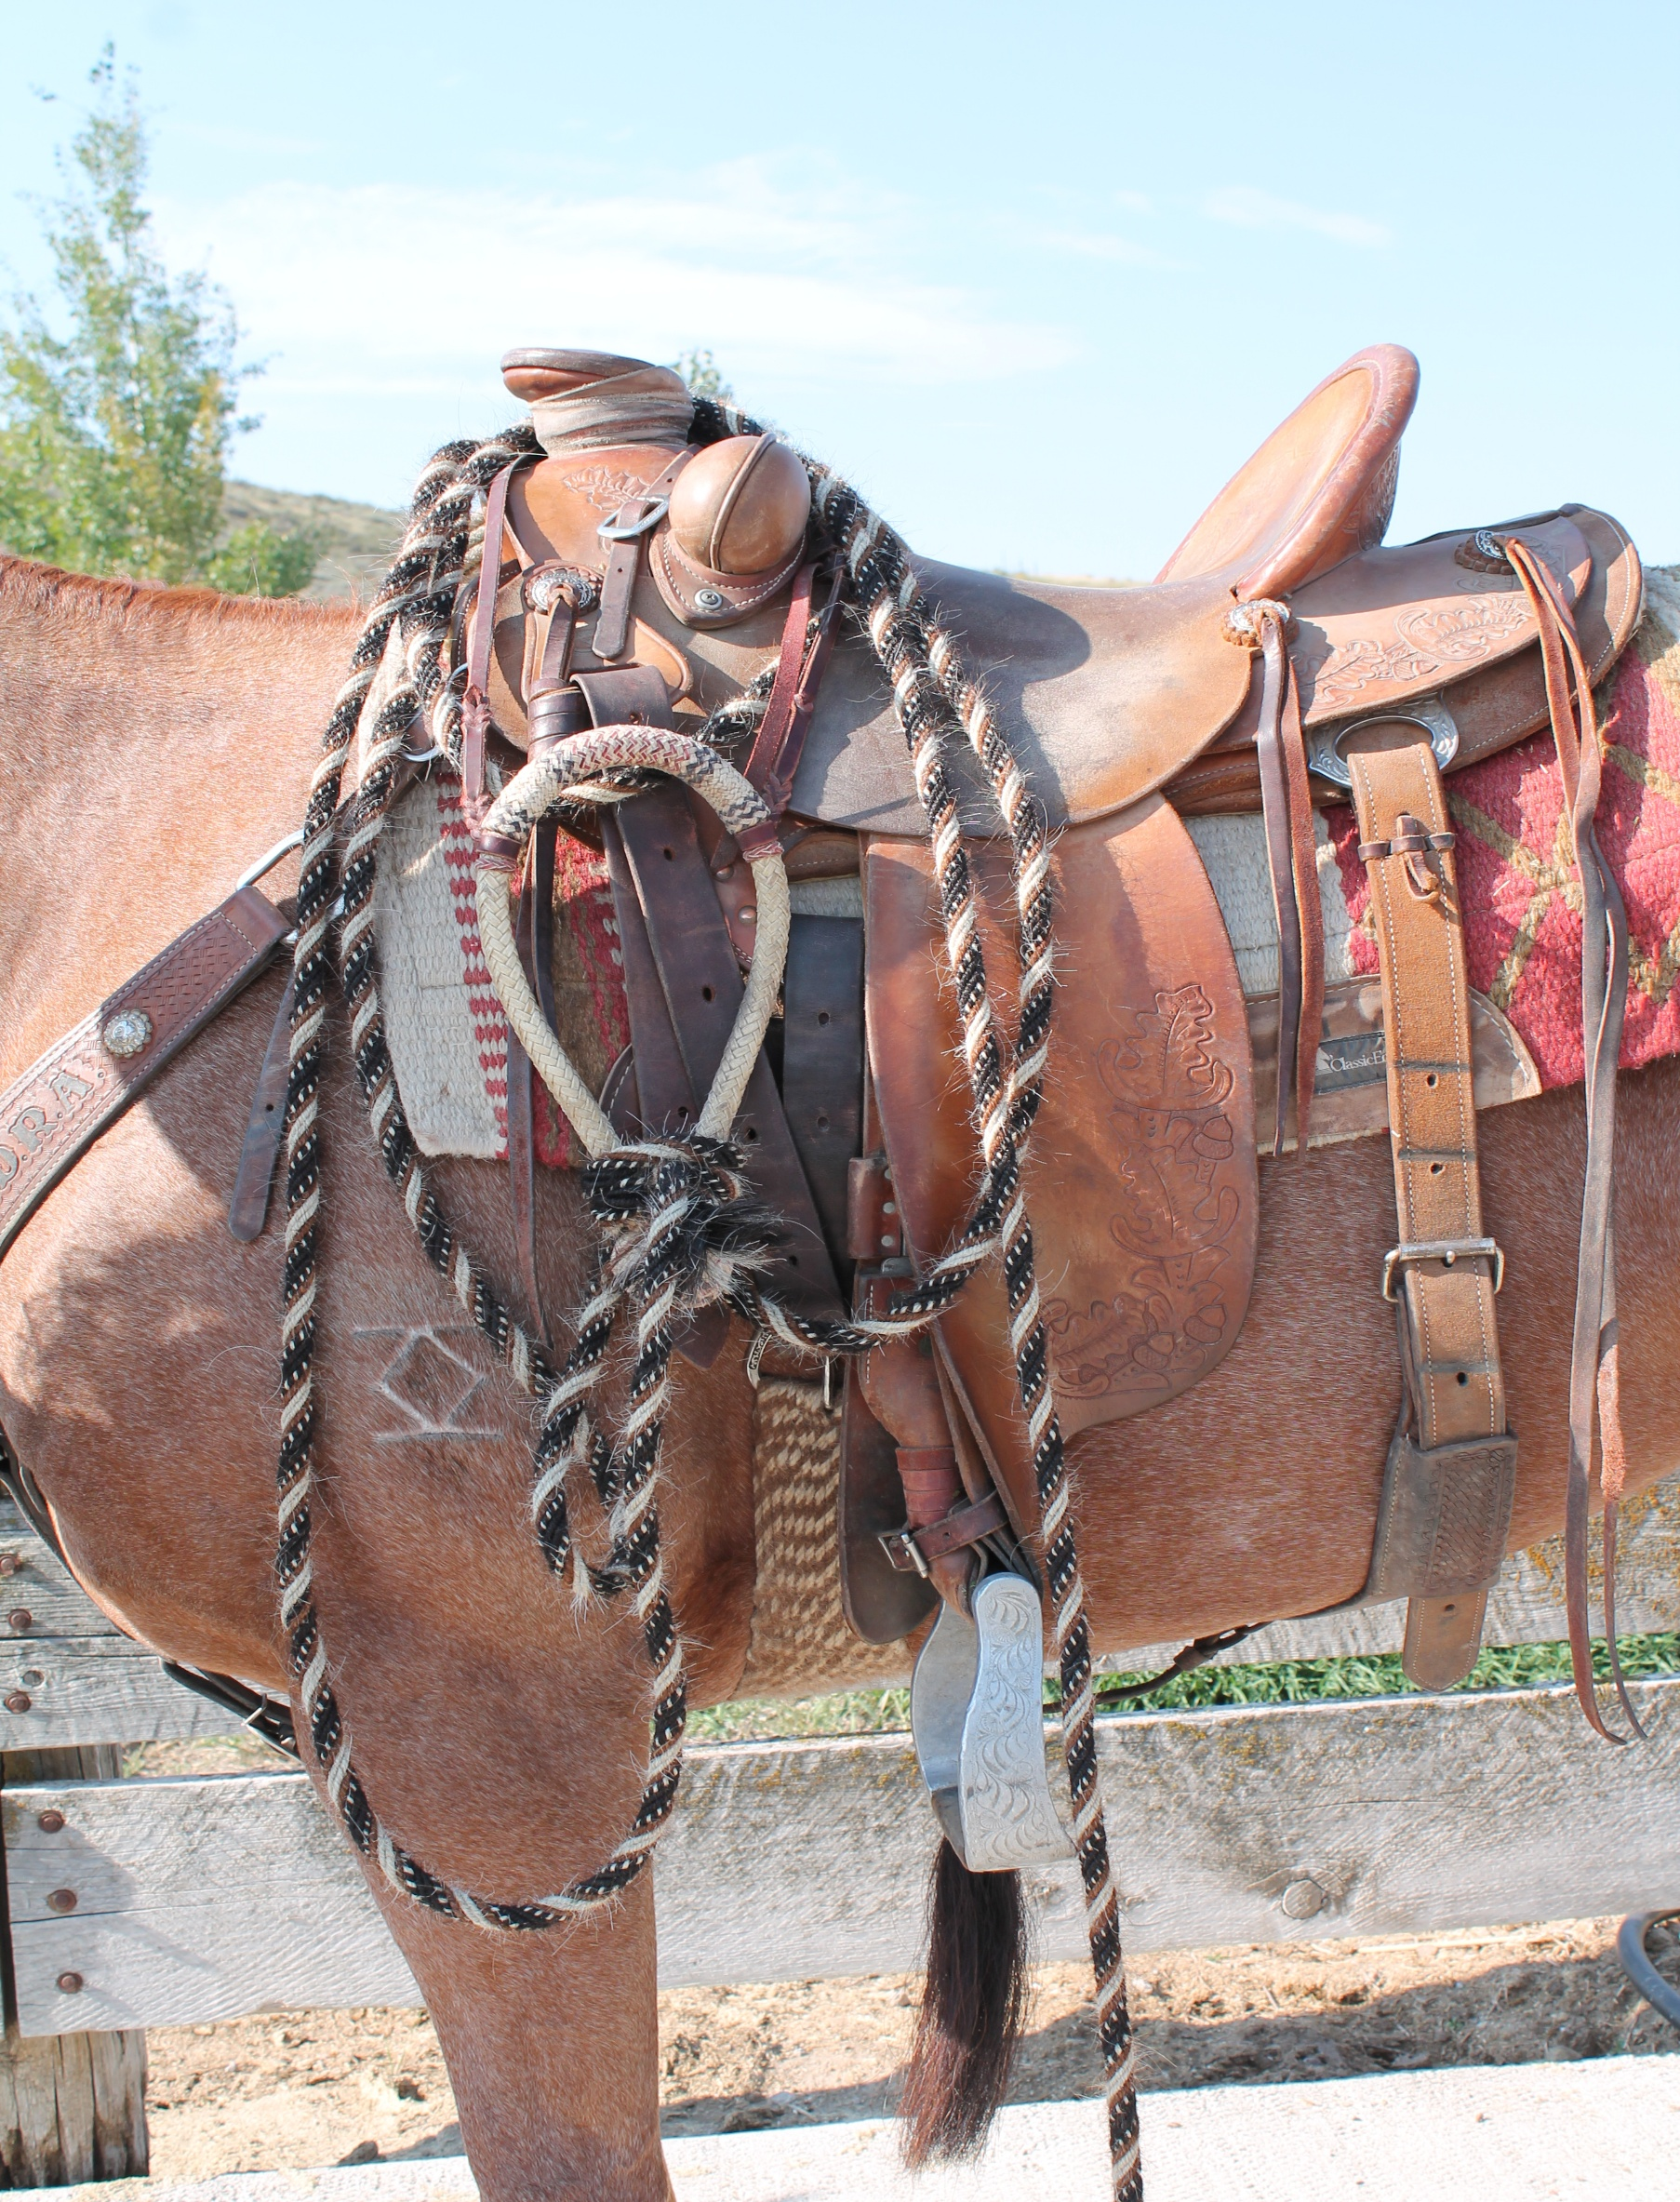
Winter Symposium Agenda

CPU Business Meeting – 1:00pm Start

Welcome, Chairman Bill Wright
Minutes from last (joint) meeting, Jo Kirkwood
Election, or Re-Election of Vice Chairman - Kenny Hall
Appointment to Board (replace Greg, inactive) - Carol Messerley

CPU President Darrell Holden - Remarks
CPU Treasurer's Report - Jeane Wood
Election of Vice President - Rod Miller
Discussion: Group feedback on meeting, discussion & planning for Heritage meeting (date, etc.) (Invite members to suggest nominations to Darrell & Rod)
Other CPU business as needed

Utah IWMA Business Meeting

UTAH IWMA President Dale Major - Remarks
IWMA Treasurer's Report - Carol Messerley
Discussion: Meetings- far south and far north have lower attendance, how can we improve?
Election of one additional IWMA board member
Other IWMA business as needed

General Business Discussion

Seed Money Proposal (refine, submit to membership) – Jo Kirkwood
Web Page Update - Kathy Smith
Signups for tonight’s show – Jo Kirkwood

Afternoon Workshops/Presentations

What Elko Means To You – Presentation by Rod Miller

Group Dinner
Provided by Veterans Home

Veterans Show
Starting Time to be Determined

